The Four B’s
On the Sport grounds
Be respectful
- Include others in your games
- Use a pleasant voice
- Share equipment fairly
- Line up when the whistle blows
Be responsible
- Use equipment the way it is designed to be used
- Put equipment away
- If you’re angry, take time to cool off
Be honest
- Take responsibility for your actions
- Get help if someone is in trouble
Be safe
- Don’t use full power (think 50% safe/50% fun)
- Wear appropriate clothing
- Keep your hands and feet to yourself
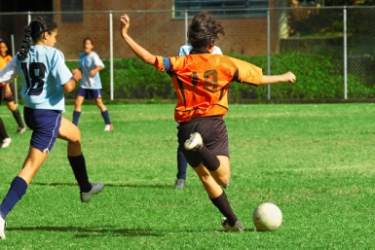
- Get permission from an adult before you leave the Sport grounds

