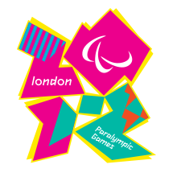
PARALYMPIC GAMES LONDON 2012

The Paralympic Games are a major international multi-sport event where athletes with a physical disability compete; this includes athletes with mobility disabilities, amputations, blindness, and cerebral palsy. There are Winter and Summer Paralympic Games, which are held immediately following their respective Olympic Games. All Paralympic Games are governed by the International Paralympic Committee (IPC).

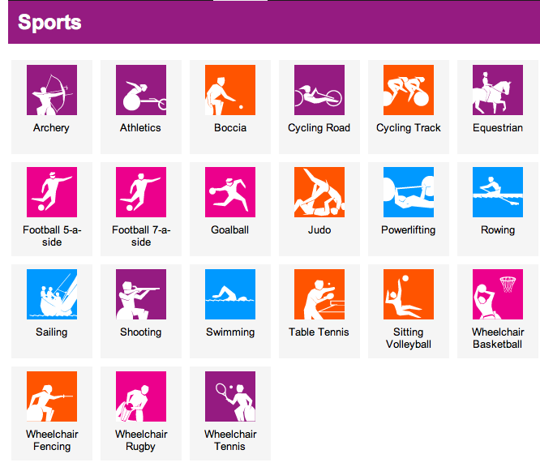
Facts:
- Once every two years
- Winter and Summer Games
- Start 29th August ‘12
- Finish 9th September‘12
- 166 Teams
- 503 event in 21 Sports
