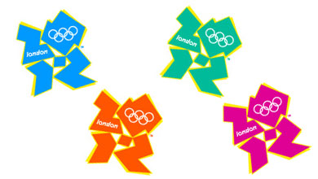
OLYMPIC GAMES LONDON 2012

London 2012’s ambition is to create a Games for all, where everyone is invited to share and enjoy
the experience.
The world will come together through sport and culture to celebrate like never before!
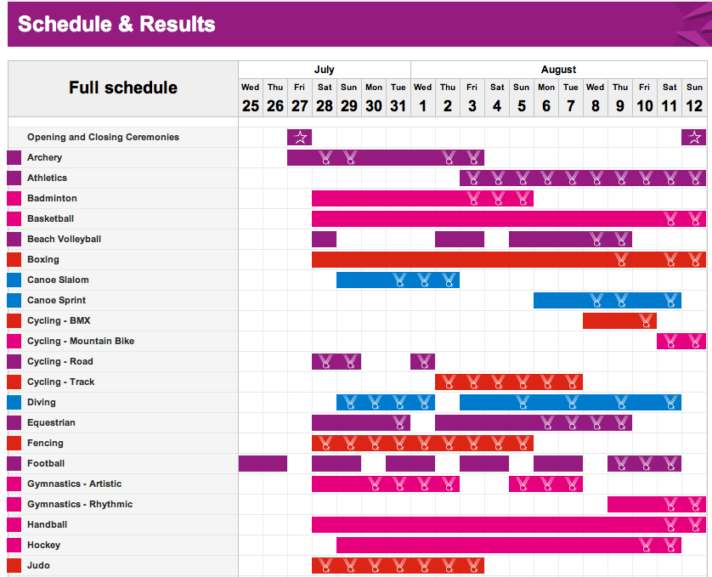
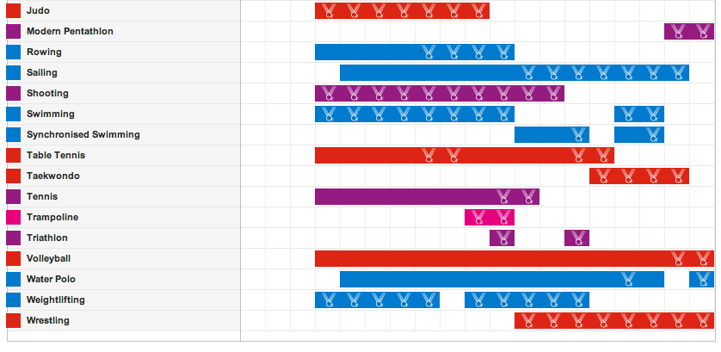

Facts:
- Once every two years
- Winter and Summer Games
- Start 27th July ‘12
- Finish 12th August‘12
- 205 Countries
- 10.500 athletes
- 302 events in 26 sports

