ANCIENT GAMES
Traditional playground games – played without the help of a parent of teacher with very little to no equipment.

HULA HOOPING
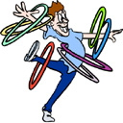
A HULA HOOP is a toy hoop that is twirled around the waist, limbs or neck. Children and adults around the world have played with hoops, twirling, rolling and throwing them throughout history.

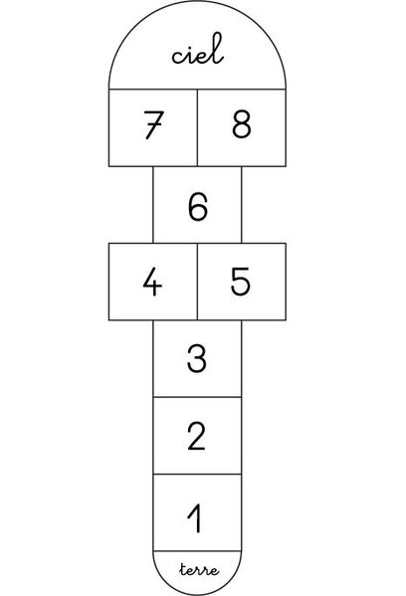
HOP SCOTCH
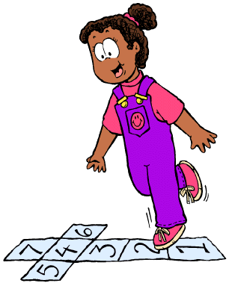
The first player tosses a stone, coin or bean-bag, into the first square. The marker must land completely within the square, cannot touch a line or bounce out. The player hops through the course, skipping the square with the stone in it. Single squares are hopped on one foot. side by side squares are straddled. At the last marker make a jump turn and return through the course (square 9, then squares 7 & 8, etc). Pick up your stone and skip that square. You continue to toss the stone into the next number, repeating the jumps, until you are out (stepped on a line, fell etc).

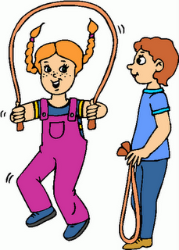
JUMP ROPE

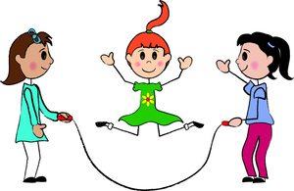
Jumping rope or skipping rope is the primary tool used in the game of skipping played by children and many young adults, where one or more participants jump over a rope swung so that it passes under their feet and over their heads. This may consist of one participant turning and jumping the rope, or a minimum of three participants taking turns, two of whom turn the rope while one or more jumps. This is called long rope.

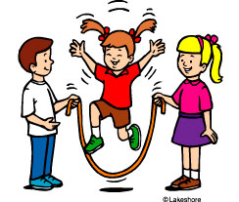
Some of the techniques that can be used when jumping rope are:
Basic jump or easy jump
This is where both feet are slightly apart and jump at the same time over the rope. Beginners should master this technique first before moving onto more advanced techniques.
Alternate foot jump (speed step)
This style consists of using alternate feet to jump off the ground. This technique can be used to effectively double the number of skips per minute as compared to the above technique. This step is used for speed events.
Criss-cross
This method is similar to the basic jump with the only difference being that while jumping, the left hand goes to the right part of the body and vice versa for the right hand, with arms crossing in front of the body.
Side Swing
This is a basic technique where the rope passes the side of the skipper's body, without jumping it. Usually the skipper performs a basic jump after a side swing, or a criss-cross.

EB(front-back cross)
This is similar to the criss-cross except one arm crosses behind the back.
Double under
To perform a double under, the participant needs to jump up higher than usual while swinging the rope twice under his feet. It is possible to have the rope swing three times under the feet (triple under). In competitive jump rope, triples, quadruples ("quads"), and quintuples ("quins") are common.
Double Dutch
Double dutch is a game in which two long jump ropes turning in opposite directions are jumped by one or more players jumping simultaneously.
Toad
The toad is a more complicated trick where the jumper performs the "Cross" manoeuvre with one arm crossing under the opposite leg from the inside.
Crougar
The crougar is a trick where the jumper jumps in a normal open jump, but with one arm hooked under the same leg.
Awesome Annie
This is where the jumper alternates between a crougar and a toad without a jump in between.
Inverse toad
Similar to the toad, except the arm crosses the same leg from the outside (rather than the opposite leg from the inside).
Elephant
A cross between the inverse toad and the toad, where both arms cross under one leg, rather than one.
Frog/Donkey kick
This is a variation of a handstand, with a beginner version and an advanced version. In the beginner version, the jumper does a handstand, comes down and then pulls the rope under. In the advanced, the jumper pulls the rope while coming down from the handstand.
Combination jumps
There are many more difficult jump roping tricks that combine two or more of these techniques to make a single trick. These combinations can also be used in Chinese Wheel, Double Dutch, Egg Beater, triangle and Long Rope.

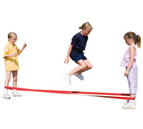
ELASTICS
or Chinese Jump Rope
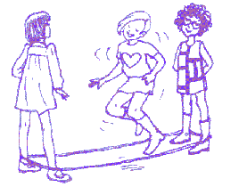
The game is played by three players with an elastic rope Two of the participants (holders) face each other about 1 meter apart, with their feet together, and the rope around their ankles. The third player (the jumper) then stands between the two sides of the rope and must accomplish a specific series of moves without making an error or pausing.
The moves involve jumping and placing the feet in some manner. Some of the more common moves are jumping so that both feet land outside the rope, both are inside the rope, one is inside and one is outside, or both are on top of the rope. These moves are called "out", "in", "side", and "on" respectively, which the two other participants chant as the player executes them.
