This journal will help me to keep track of all the activities I do during the day. Please write down what you did and for how long. Activities should be at least 10 minutes long.

***Example***

|  |  |  |
| --- | --- | --- |
| **When** | **Activity** | **Time** |
| Before school | Cycled to school | 20 minutes |
| Morning recess | - |  |
| Lunch recess | Played football | 15 minutes |
| After school | Cycled home  Played hide and seek at my house | 20 minutes  30 minutes |

***Day 1: Tuesday 3rd November***

|  |  |  |
| --- | --- | --- |
| **When** | **Activity** | **Time** |
| Before school |  |  |
| Morning recess |  |  |
| Lunch recess |  |  |
| After school |  |  |

***Day 2: Wednesday 4th November***

|  |  |  |
| --- | --- | --- |
| **When** | **Activity** | **Time** |
| Before school |  |  |
| Morning recess |  |  |
| Lunch recess |  |  |
| After school |  |  |

***Day 3: Thursday 5th November***

|  |  |  |
| --- | --- | --- |
| **When** | **Activity** | **Time** |
| Before school |  |  |
| Morning recess |  |  |
| Lunch recess |  |  |
| After school |  |  |

***Day 4: Friday 6th November***

|  |  |  |
| --- | --- | --- |
| **When** | **Activity** | **Time** |
| Before school |  |  |
| Morning recess |  |  |
| Lunch recess |  |  |
| After school |  |  |

***Weekend: Saturday 7th November***

|  |  |  |
| --- | --- | --- |
| **When** | **Activity** | **Time** |
| Morning |  |  |
| Afternoon |  |  |
| Evening |  |  |

***Weekend: Sunday 8th November***

|  |  |  |
| --- | --- | --- |
| **When** | **Activity** | **Time** |
| Morning |  |  |
| Afternoon |  |  |
| Evening |  |  |

***Day 7: Monday 9th November***

|  |  |  |
| --- | --- | --- |
| **When** | **Activity** | **Time** |
| Before school |  |  |
| Morning recess |  |  |
| Lunch recess |  |  |
| After school |  |  |

***Day 8: Tuesday 10th November***

|  |  |  |
| --- | --- | --- |
| **When** | **Activity** | **Time** |
| Before school |  |  |
| Morning recess |  |  |
| Lunch recess |  |  |
| After school |  |  |

***Day 9: Wednesday 11th November***

|  |  |  |
| --- | --- | --- |
| **When** | **Activity** | **Time** |
| Before school |  |  |
| Morning recess |  |  |
| Lunch recess |  |  |
| After school |  |  |

***Day 10: Thursday 12th November***

|  |  |  |
| --- | --- | --- |
| **When** | **Activity** | **Time** |
| Before school |  |  |
| Morning recess |  |  |
| Lunch recess |  |  |
| After school |  |  |

***Day 11: Friday 13th November***

|  |  |  |
| --- | --- | --- |
| **When** | **Activity** | **Time** |
| Before school |  |  |
| Morning recess |  |  |
| Lunch recess |  |  |
| After school |  |  |

***Weekend: Saturday 13th November***

|  |  |  |
| --- | --- | --- |
| **When** | **Activity** | **Time** |
| Morning |  |  |
| Afternoon |  |  |
| Evening |  |  |

***Weekend: Sunday 14th November***

|  |  |  |
| --- | --- | --- |
| **When** | **Activity** | **Time** |
| Morning |  |  |
| Afternoon |  |  |
| Evening |  |  |

***Day 14: Monday 15th November***

|  |  |  |
| --- | --- | --- |
| **When** | **Activity** | **Time** |
| Before school |  |  |
| Morning recess |  |  |
| Lunch recess |  |  |
| After school |  |  |

After collecting data about my physical activity, I have decided to make these choices in my everyday life…



I have decided this because ________________________________________________________________________________________________________________________.

It went ___________________________, because_____________________

____________________________________________________________.

Fit! Active! Me!

(draw pictures of you being active)

|  |  |
| --- | --- |
| Morning | At school |
| After school | With mum and dad |

**ACTIVITY PYRAMID**

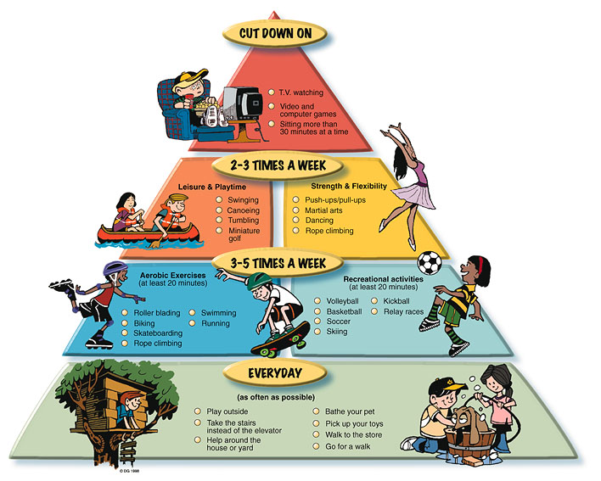

**Fill in your activity pyramid**

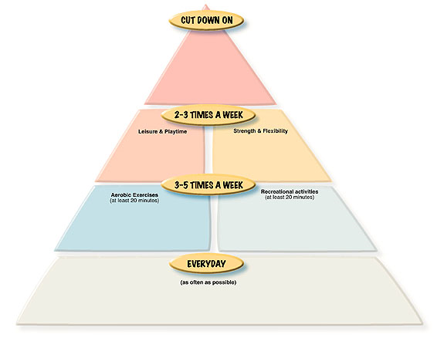

**MUSCLE WORKSHEET**

**– What muscles do we use? Colour in the used muscle group.**

|  |  |  |
| --- | --- | --- |
| **http://www-antique-ceiling-fans-blades.co.cc/wp-content/uploads/2009/03/human-body-outline.jpgActivity 1: Running** | **Activity 2: Skipping**  http://www-antique-ceiling-fans-blades.co.cc/wp-content/uploads/2009/03/human-body-outline.jpg | **http://www-antique-ceiling-fans-blades.co.cc/wp-content/uploads/2009/03/human-body-outline.jpgActivity 3:** |
| **Activity 4:**  http://www-antique-ceiling-fans-blades.co.cc/wp-content/uploads/2009/03/human-body-outline.jpg | **Activity 5:**  http://www-antique-ceiling-fans-blades.co.cc/wp-content/uploads/2009/03/human-body-outline.jpg | **Activity 6:**  http://www-antique-ceiling-fans-blades.co.cc/wp-content/uploads/2009/03/human-body-outline.jpg |



NAME:

CLASS:

C:\Documents and Settings\rvanwijngaarden\Local Settings\Temporary Internet Files\Content.IE5\XO2LDX0A\j0424740[1].wmf

C:\Documents and Settings\rvanwijngaarden\Local Settings\Temporary Internet Files\Content.IE5\LXF71CPG\j0436041[1].wmfC:\Documents and Settings\rvanwijngaarden\Local Settings\Temporary Internet Files\Content.IE5\XO2LDX0A\j0232649[1].wmfC:\Documents and Settings\rvanwijngaarden\Local Settings\Temporary Internet Files\Content.IE5\G0J51F34\j0440554[1].wmf