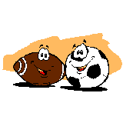**PHYSICAL EDUCATION**

**“Me and Physical Education”**

# Name ______________________ Class **3__________**

### Always Often Sometimes

|  |  |  |  |
| --- | --- | --- | --- |
| I enjoy PE lessons | ☺ ☺ | ☺ | ☹ |
| I try my best | ☺ ☺ | ☺ | ☹ |
| I like to play with my classmates | ☺ ☺ | ☺ | ☹ |
| I like to take risks | ☺ ☺ | ☺ | ☹ |

# **My favourite sporting activity**

**, because**

**I am really good at**

**, because**



**I would like to get better in**

**, because**

